**Week1**

**8, July 2019 ~ 14, July 2019**

**MyeongGeun(Matthew) Jo in UCSD**

In first week, I learned about basic things that database, system architecture, reference model, android, php, python. The most interest part is database.

I learned database before. It was useful to make a schema. I made DB schema and sign-up procedure.

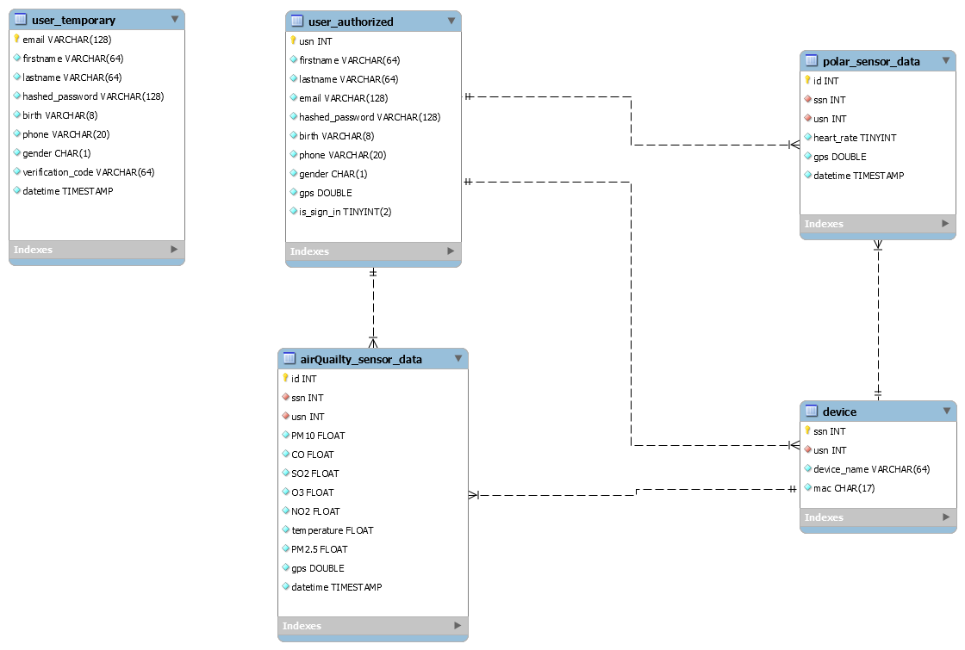

It is shema what I made. I learned many things during I made it. First. User management during the sign-up. When we sign up some web page like ‘Amazon’, we press the sign up button, and check email and click the link what I received for account authorize. At that time, We don’t know when they click the link. Maybe one week or maybe one month. At that reason, we do hard to management table, cause in user table has many data about not authorize yet. It is the reason what we make 2 tables about user. ‘user_temporary’ Table is store that not authorize user data. When they authorize, the data move to ‘user_authorized’ table. It expect simple, useful for user management. I learned how to store password. But I didn’t learned about how to make hased password. I just study when I store password, I should using hash. Besides this, I studied sequence number that managed user data for separate each tuple.

In sign up procedure and system architecture, I studied about how to architect first when I develop something. System architecture display some function about each part. For example, Server is doing many things like, execute query, hashed password etc. Just write down on the each part function like this.

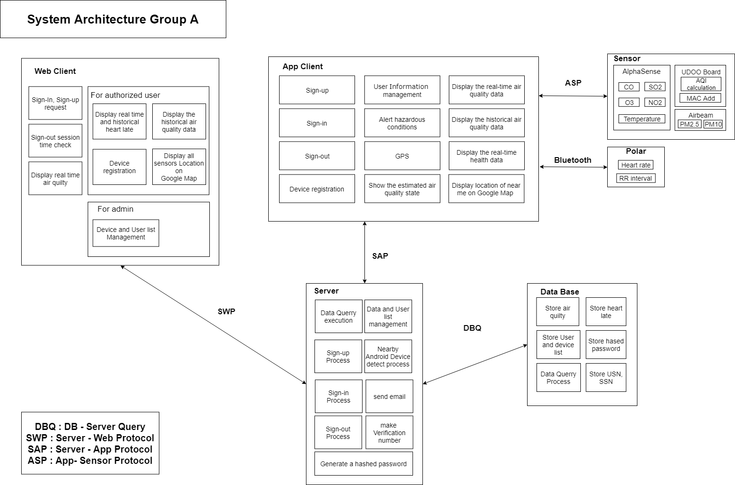

It is system architecture of us. I think it is really useful when I make some platform. Really need it. I wish in korea university should teach like that. Some procedure too.

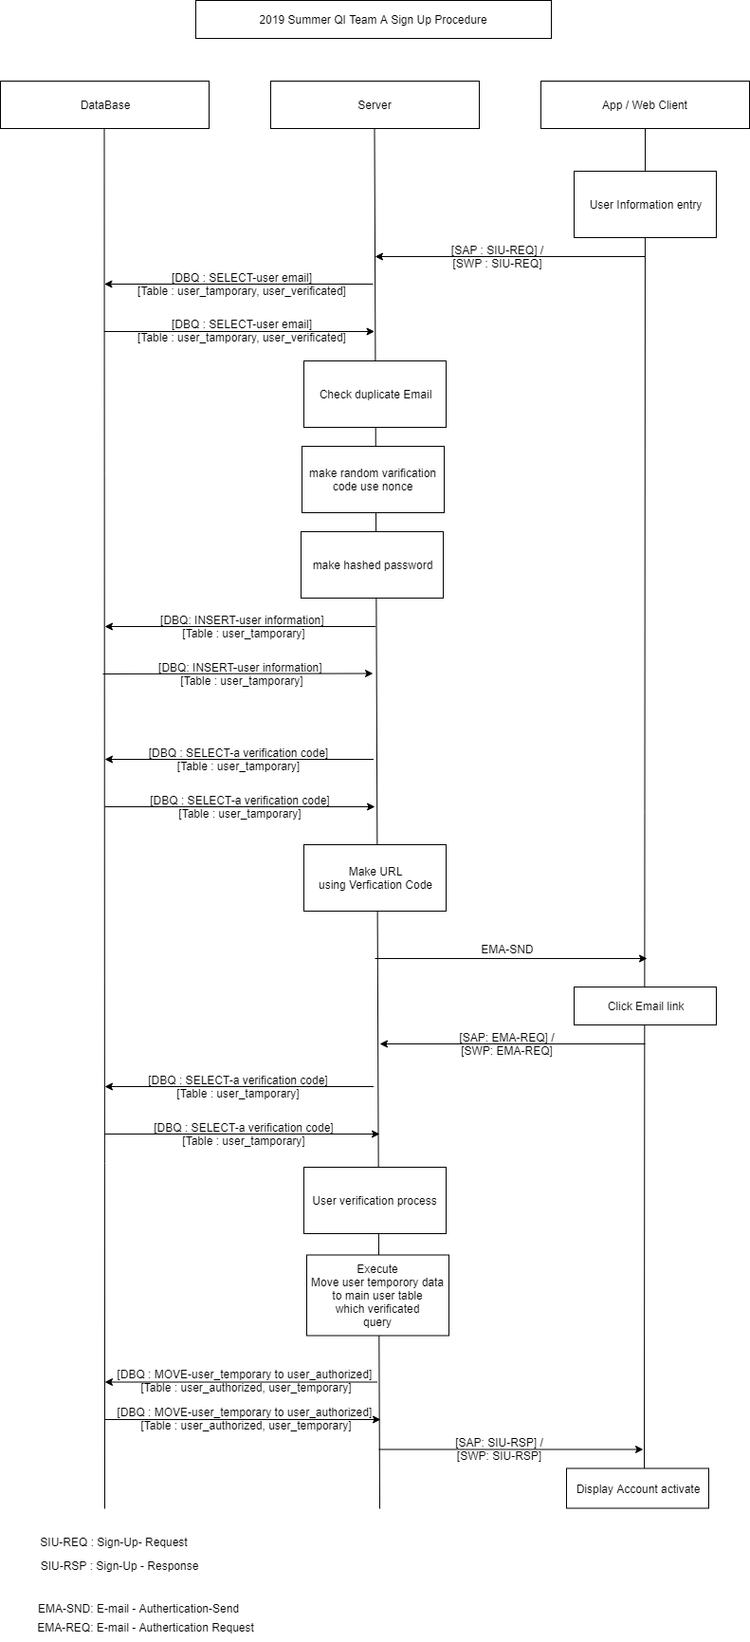

It is sign-up procedure what I made. I think we should study about architecture, and procedure before we graduate. Because It is easy to know what I want to. Some people saw that and just code. Than it will be perfect program what I want. Of course, procedure and architect must be perfect too.

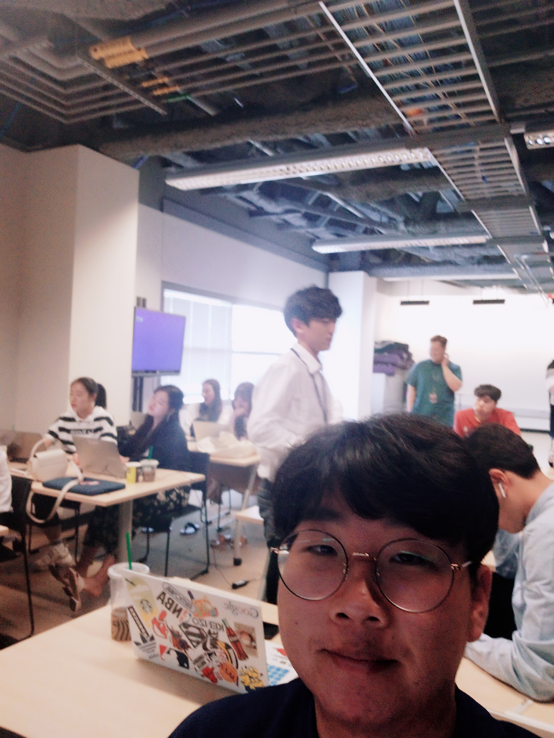

* View in Lecture room

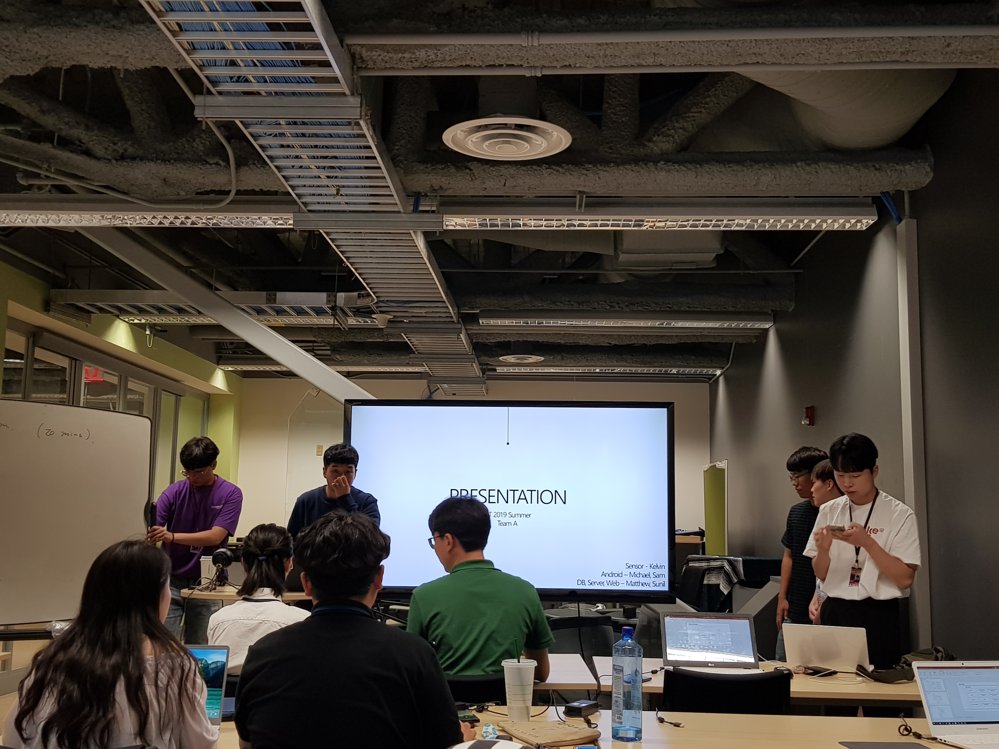

* First present